**DATA FLOW DIAGRAM**

**CONTEXT LEVEL**

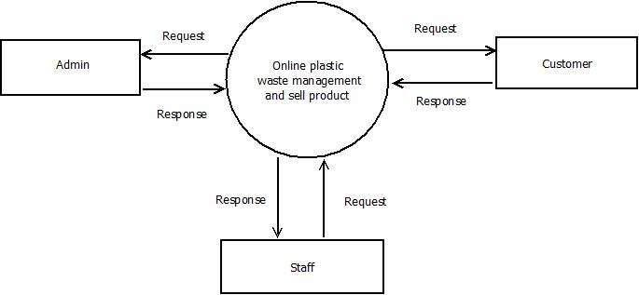**LEVEL 1: ADMIN**

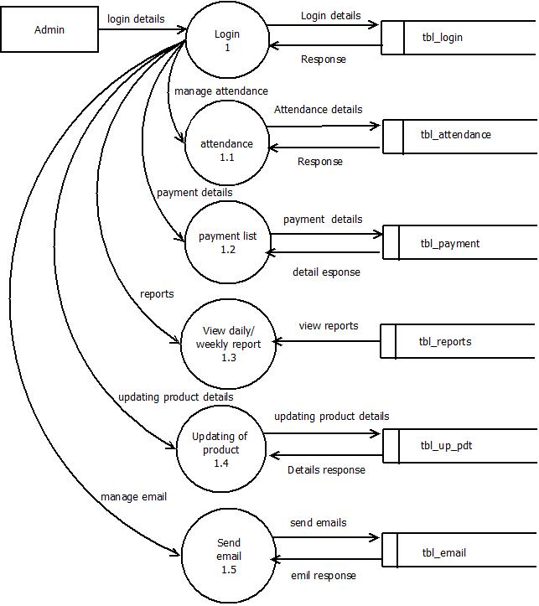

**LEVEL 1: CUSTOMER**

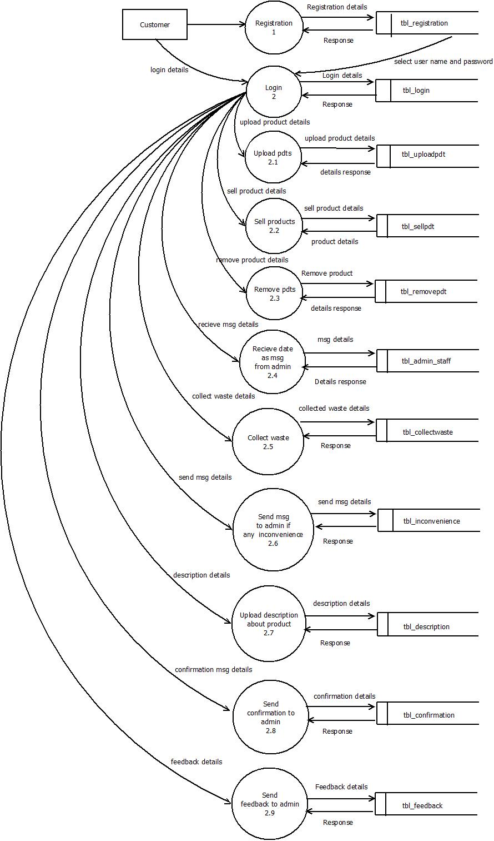

**LEVEL 1: EMPLOYEE/STAFF**

